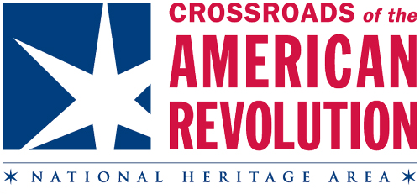

2017 Revolutionary Spirit Night at the All-Star Game

Baseball fans will find themselves immersed in Colonial-era New Jersey on Wednesday, July 12, 2017 as the Somerset Patriots celebrate Revolutionary Spirit night during the 2017 All-Star Game at TD Bank Park in Bridgewater. This event combines the All-American sport of baseball with the patriotic pride of the spirits of ‘76!
Attendees will converse with George Washington, Ben Franklin, Thomas Jefferson, Alexander Hamilton, Elizabeth Schuyler-Hamilton and other costumed reenactors representing several New Jersey historic sites and interpreter groups. Fans will also get to see a Revolutionary war encampment, cannon demonstrations, colonial hearth cooking, numerous other demonstrations and kids’ activities at the ballpark.
Become a sponsor today! For more information contact Program Manager, Kate Brindle at kbrindle@revolutionarynj.org or 609-341-3246

Four sponsorship levels: Double, Triple, Home Run, and Grand Slam

Grand Slam ($2000+)-
- A 30 second spot for a commercial or advertisement on the big screen inside the ballpark on game night
- A PA announcement during the All-Star game
- Your logo the calendar event listing
- “Sponsored in part by” status on Crossroads’ exhibit game-day sign
- Named as a sponsor in three social media posts
- Your business’s name, link and logo in the July newsletter
- 15 tickets to the game

Home Run ($1000)-
- A PA announcement during the All-Star game
- Your logo on the calendar event listing
- “Sponsored in part by” status on Crossroads’ exhibit game-day sign
- Named as a sponsor in two social media posts
- Your business’s name, link and logo in the July newsletter
- 10 tickets to the game

Triple ($500)-
- Your logo on the calendar event listing
- “Sponsored in part by” status on Crossroads’ exhibit game-day sign
- Named as a sponsor in one social media post
- Your business’s name and link to your site in the July newsletter
- 5 tickets to the game

Double ($250)-
- Your logo on the calendar event listing
- “Sponsored in part by” status on Crossroads’ exhibit game-day sign
- Your business’s name and link to your site in the July newsletter
- 2 tickets to the game

