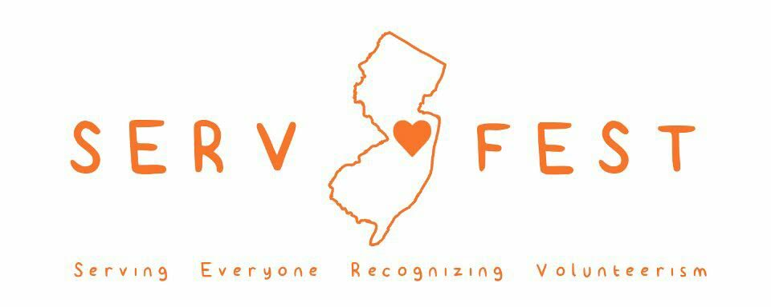

Dear friend,

Our first annual SERV Fest will take place on August 20, 2016 at the Morristown National Historic Park. On this eventful day, NJ SERV Fest will bring the public together to engage with local non-profits to promote and celebrate genuine and generous volunteerism. As this festival was created to showcase the amazing community service done by local individuals, we would like to invite your organization to be apart of our event! This is the perfect opportunity for your association to publicize itself and make the citizens in our community aware of the great things that you do.

This year is special since the event will also celebrate the 100th anniversary of the National Parks, and as such, we are expecting attendance to be at 1,000+. To honor the importance of giving, we would like your organization to have an interactive table that helps the public better understand your cause and maintains interest and engagement among the visitors. For example, you can have a “pin the bird on the tree” game if your organization benefits the environment. As we offer many different levels of participation, our event is a great way to promote compassion and rightly stand out in the community. Below is a breakdown of the prices to attend.

BASE PARTICIPATION: $25 refundable deposit
Includes participation, name, and description in Ad book
BASE PAID PARTICIPATION: $50
Includes Base Participation plus table and logo in Ad book
AD PARTICIPATION: $100
Includes Base Paid Participation plus ½ page ad in Ad book
SPONSOR PARTICIPATION: $300
Includes Ad Participation plus logo on t-shirts and other marketing materials

(Tabling at this event is FREE of charge. The $25 refundable deposit is simply a placeholder to secure your spot while an additional $50 covers the cost of purchasing a table and chairs if necessary. Additional support covers the cost of running the festival.)

We hope that we can count on you to help make this event a true success! If you would like to secure a tabling spot or have any questions, please feel free to contact us!

Sincerely,
Your NJ SERV Fest Team
njservfest@gmail.com

Heather Tedesco Andrew String
Head Organizer Community Service Outreach
ourinspiration@slay.com andrewstring123@gmail.com

njservfest@gmail.com  http://njservfest.weebly.com/

