DEBORAH PETERSON, CULINARY HISTORIAN
Celebrating over 34 Years of Colonial Domestic Skills Research & Sharing
deborahjpeterson@comcast.net; 215-256-9399

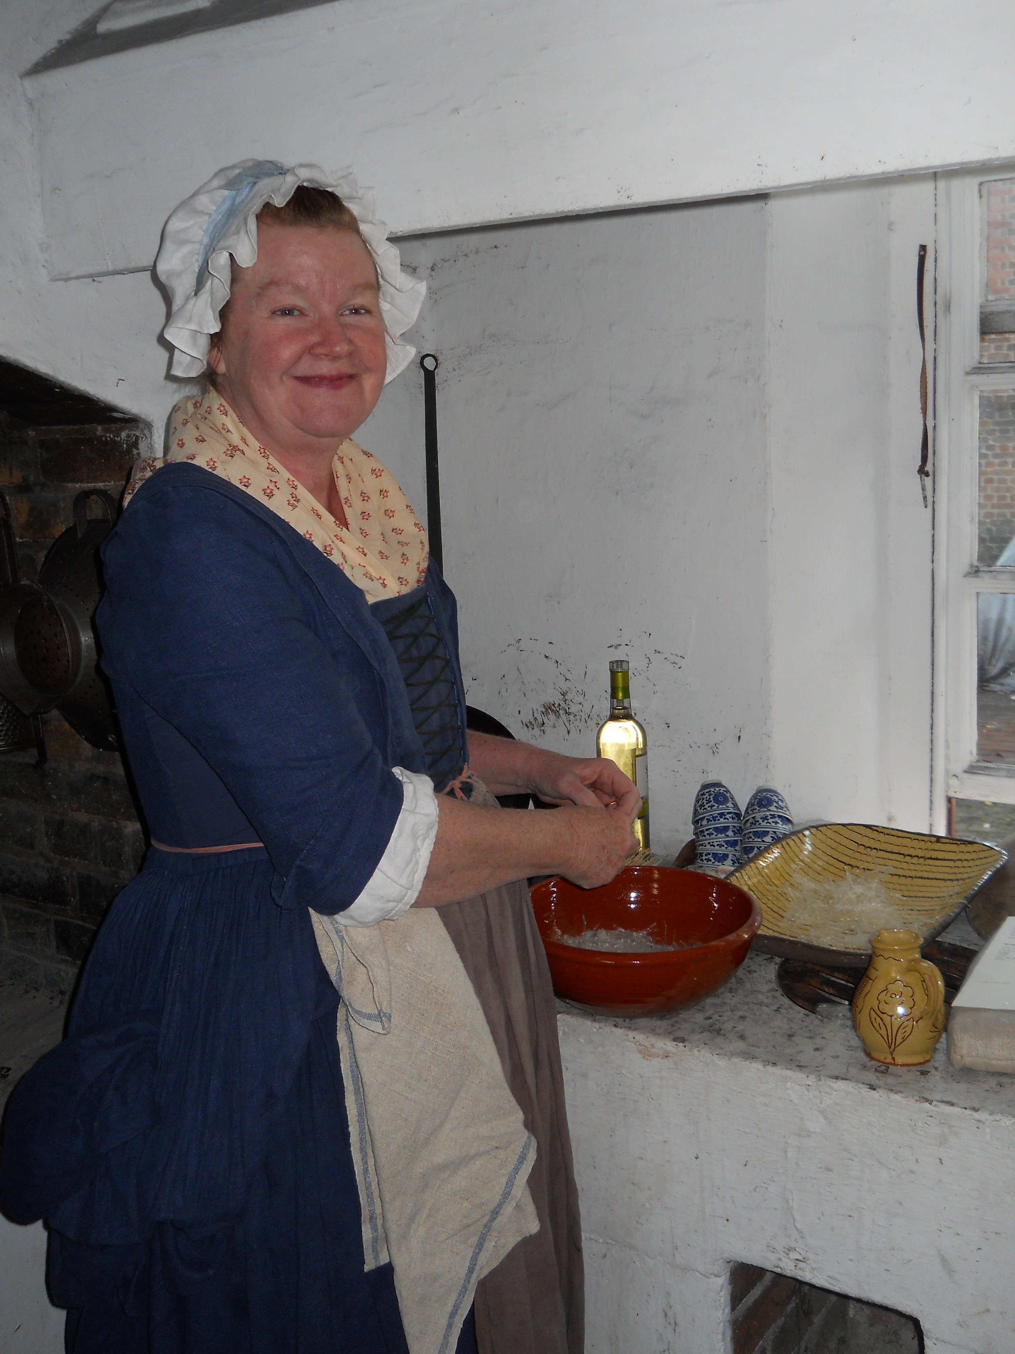
At the Governor’s Palace Kitchen

Programs offered:

- NEW! When the Armies Came to Your House is a fascinating PowerPoint program that tells what it was like for many people during the Revolutionary War when the soldiers, English & Continental, came and took your food, stock and other assorted goods. Not a pretty story.

- NEW! Breaking Through Language Barriers Encountered by Period Cooks - The focus of this PowerPoint presentation helps today’s cooks understand colonial language shifts from 18th century to the modern day. It can be daunting to interpret period cookbooks, diaries, letters, journals, almanacs, and newspapers. Add to that the use of unfamiliar words, terms, punctuation, measurements, punctuation, and often difficult handwriting, and the challenge becomes even greater. A hand-out is supplied.

- Coffee, Chocolate, Tea, Spices, and Many Other Items too Tedious to Mention: 18c Imports into the Colonies – This PowerPoint program covers imports into the colonies as coffee, chocolate, imported and patriotic teas, spices, sugar, salts, peppers, food colorants, isinglass, hartshorn, gums, leavenings, oils, pickles, sweetmeats, syrups, jellies, rose and orange-flower waters and many, many other items that were part of our nation’s imported foods. A hand-out is supplied.

- Seasonal Foodways - This PowerPoint presentation brings to light just how dependent colonial Americans were on the seasons of the years for their food. It also touches on the goods imported into the colonies. A hand-out is supplied.

- Isinglass, Trotters and Hartshorn (Jellies!) - A show-n-tell and PowerPoint program about gelatines in English colonial America. We know them today as a Jello™ product. A hand-out is supplied.

- Sugar: from Harvested Cane to the Table - This PowerPoint presentation deals with the mysterious colonial sugar making process. Sugar was much desired in the colonies. Beginning with pressing the juice from the cane, explaining and illustrating the many steps and the equipment needed to do this. The different kinds of sugars will be discussed along with their packaging, export, marketing and uses in the home. A vocabulary hand-out will be given.

- Sweet-meats, Sugar plumbs, Suckets, Comfits (and Other 18th Century Sweets) - This is a show-n-tell and PowerPoint presentation that details the diverse selection of ‘sweets’ that were available in English colonial America... just not for the kids… A hand-out is supplied.

- Sweet-meats. A lively and fascinating workshop where participants make, eat, and take home a variety of sweetmeats from the colonial era. Lots of sugar work. Recipes supplied.

- Sugar-plums! Explore how sugar-plums got their name! This PowerPoint program is a delightful prelude to Christmas planning. Some tastes and receipts (recipes) will be supplied.

- Chocolate! This PowerPoint program covers chocolate in America since the 17th century. Tastes, receipts (recipes) and a hand-out are supplied.

- Colonial Chocolate - in this hands-on workshop, participants make and consume several dishes made from period receipts featuring chocolate as it was imported into colonial America. Receipt (recipe) book supplied.

- Packaging in the 18th Century: What Came in What? This PowerPoint presentation makes sense of the somewhat surprising and bewildering world of packaging products for shipment and sale. A hand-out is supplied.

- Exotic Spices of the Eighteenth Century; a PowerPoint Program illustrating the various spices imported and used by our English colonial ancestors. A hand-out is supplied.

- Ice Cream! - Make and eat your own hand-made ice creams! Each session shall pre-select three flavors (before the class meets!) from a list of authentic colonial flavors including Barberry, Raspberry, Strawberry, Apricot, Pine Apple, Currant, Pistachio, Brown Bread, Ginger, Coffee, Chocolate, Orange, Lemon, Millefruit, Peach, or Cherry. A hand-out is provided. An excellent hot weather activity!

- Making Colonial Ice’d Creams. This is a lovely way to spend a hot day. We will be using a colonial sabotier to make an assortment of delicious ice’d creams.

- Hands-on Hearth Cooking Demonstrations and Classes, tailored to your needs, are available.

NOT FOOD RELATED, BUT CAREFULLY RESEARCHED
AND AVAILABLE FOR PRESENTATION:

- Clothing the Common Sort: What did our Laboring English Colonial Ancestors Actually Wear? This show-n-tell program explains the clothing of laboring English colonial people with emphasis on the common sort, children’s, women’s and civilian men’s working clothes in the third quarter of the eighteenth century. A hand-out is supplied.

- The Clothing We Wear, Its Reasons, the Order it goes on, or Why Do I HAVE to wear all this stuff? A primer for volunteers who want to look right for their site, but wonder why the clothing is so complicated. This program is tailored to your organization or site’s needs. It explains the ‘why’ of eighteenth-century English colonial clothing so staff and volunteers better understand the clothing of the time and avoid making common mistakes. A hand-out is supplied.

- The Common Pin; Pins were very important in colonial America used not just for sewing, but in clothing use. This PowerPoint program provides a careful look at the straight pin, the surprising many steps to its manufacture, its importance and uses in the eighteenth century. A hand-out is supplied.

- A Visit with MOTHER GOOSE! - Deborah as Mother Goose! Dressed in period-correct colonial clothing, “Mother Goose” comes to visit pre-school and kindergarten age classes and groups with appropriate stories, rhymes & riddles. A very interactive visit with lots of excitement! In her basket of goodies are all sorts of charming stuffed animals and accessories to add to the fun.

- Sweet-bags, or what we today call sachets. This hands-on activity allows participants to make the historically correct sweet-bags that were so useful in scenting clothing and controlling insect infestations. This is a cut above just making a sachet, using ingredients that are not quite so common in this day and age.

- Marble Paper Workshop. Participants get to make their very own marbled papers. Great fun and lots of lovely take-home projects. Wear old clothes!

Most PowerPoint programs run for about an hour with time after for later discussions and queries.

I do have my own PowerPoint projector.

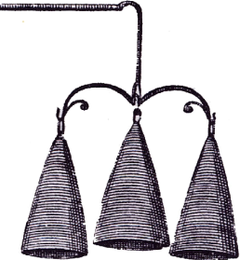
Please contact Deborah for rates and to make arrangements. Special programs can be arranged!

