“The Annual Battle of Bound Brook”

April 9-10, 2022
17 von Steuben Lane, South Bound Brook, NJ 08880

Registration Opening in January

4 Battles and 2 Free Meals! plus morning coffee and muffins!
- Soldiers’ Encampment at the Abraham Staats House, South Bound Brook ~ Military and Camp Followers portraying life in the camps
- Battles, Tacticals, Drills ~ Re-enactment on actual Battle of Bound Brook ground of Cornwallis and Ewald’s assault, Street Battles, Drilling, Tacticals, and Maneuvers Sat/Sun
- Programs, Speakers, House Tours: At the Abraham Staats House ~ Lectures and Exhibits highlighting New Jersey during the American Revolution. Rug Hooking Demonstrations Saturday 10am-4pm Hunterdon County Rug Artisans’ Guild in New Jersey (hcrag.com). Lecture Sunday 1-2pm Bob Mayers presents his recently published book, "Middlebrook the Revolutionary Campground That Saved America" followed by a book signing (www.revolutionarydetective.com).
- Firewood, Water, & Straw provided
- Meals, Social: Free Coffee, muffins in a.m. ~ Saturday lunch free for re-enactors in period clothes in Bound Brook. Free Firehouse Breakfast Buffet Sunday morning. Saturday dinner and Sunday Lunch should be planned individually by the units and may be prepared in camp or via visit to local eateries.
- Sutlers Welcome ~ As in the past no fees will be charged and if you are in period dress you will qualify for meals. Thank you for helping commemorate and continue to build on this annual event.

Registration, Directions & Schedule available at www.staatshouse.org

To Register: Fill out online and submit E-mail: bkfaulks@gmail.com or fill out form hard copy below and mail by April 1, 2022.
Insurance: Please email or mail a copy of your unit’s proof of insurance with insurance certificate noting the Borough of South Bound Brook as additionally insured by April 1, 2022.

Mail: Kathy Faulks, FASH/BBB, PO Box 115, South Bound Brook, NJ 08880
For questions - Tel: 732-469-5836. Please call if you do not receive an email receipt of registration confirmation after 7 days.

Please allow a two-week notice for accessibility and assistive services requests.
Made possible by funds from the Somerset County Cultural & Heritage Commission, a partner of the New Jersey Historical Commission and the Brough of South Bound Brook.

Please note: Social distancing rules apply. Masks required. Hand sanitizer and wipes available.

BBB REGISTRATION FORM - UNITS/Individuals – 245th Commemoration, April 9-10, 2022

NAME OF UNIT OR INDIVIDUAL: __________________________________________________________________________________________

AFFILIATION: BRITISH AMERICAN GERMAN LOYALIST INFANTRY ARTILLERY SUTLER OTHER

(SPECIFY)__________________________________________________________________________________________________________________

FOR UNIT REGISTRATION: NUMBER OF EXPECTED PARTICIPANTS:
MEN AT ARMS _________ CIVILIAN _________ MUSICIAN________ ARTISAN_________ OTHER__________

PERIOD CAMP SET UP? YES_______ NO_______
IF YES, PLEASE SPECIFY NUMBER OF TENTS—SIZE/TYPE: ________________________________________________________________

EVENT FIELD COMMANDER: _______________________________________________________________________________________________

UNIT CONTACT PERSON: ___________________________________________________________________________ Date: ________________

ADDRESS: ________________________________________________________________________________________________________________

PHONE: ___________________________________________EMAIL: ________________________________________________________________

The Annual Battle of Bound Brook – Living History Weekend!

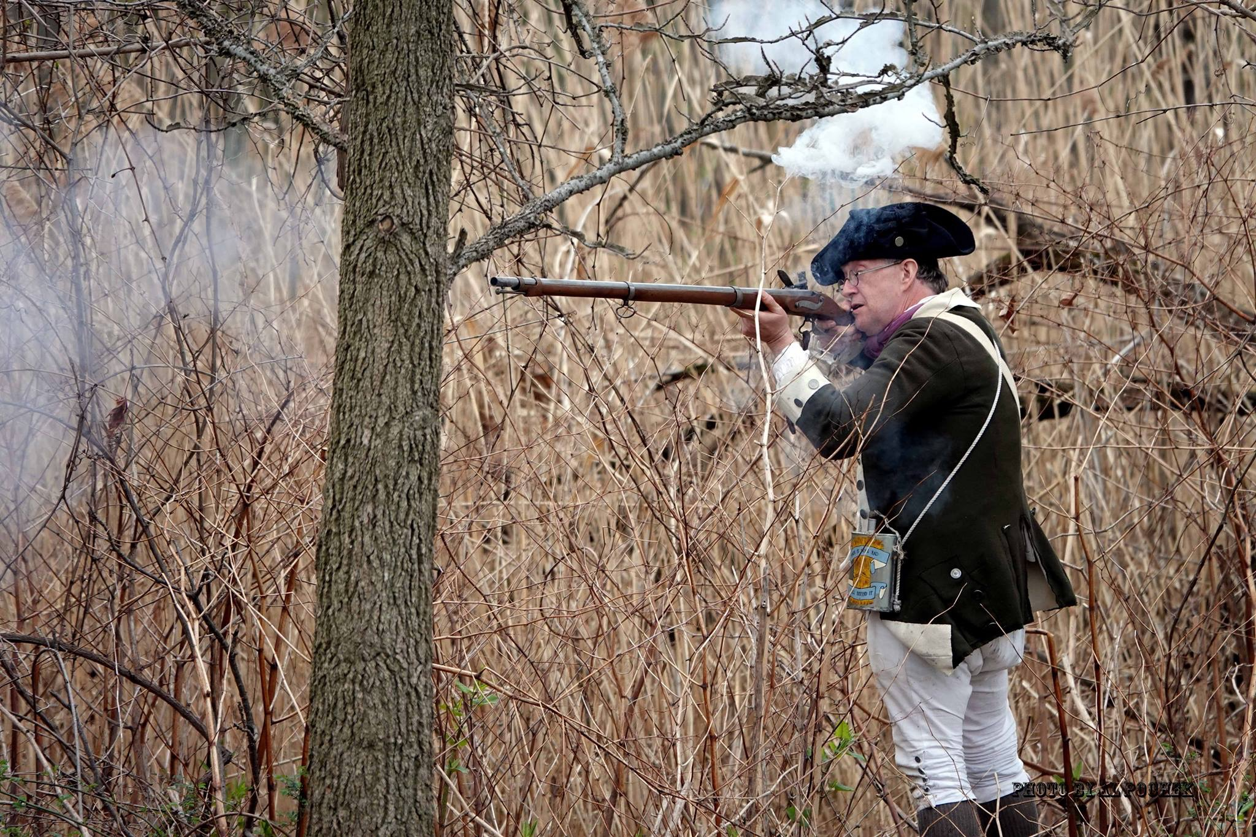
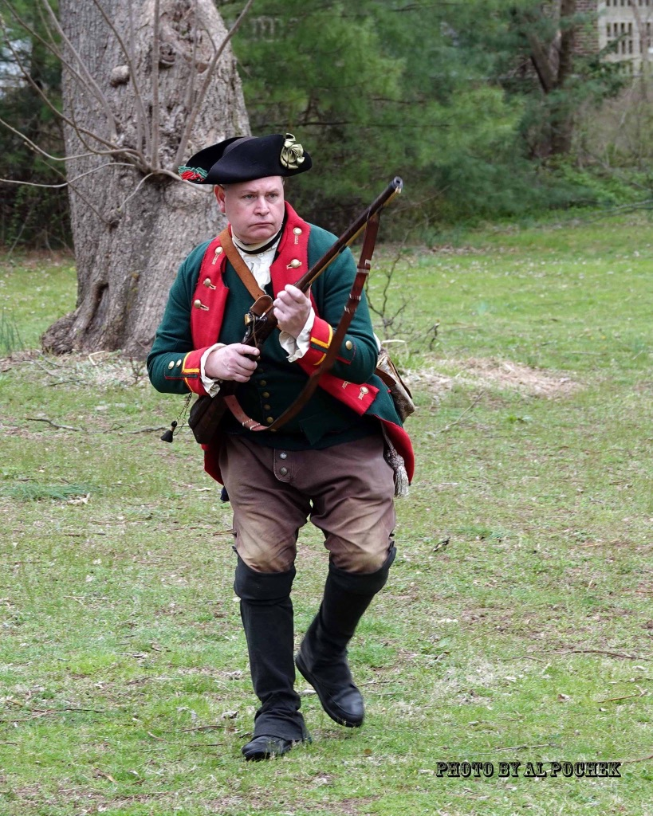
April 9-10, 2022 * South Bound Brook, NJ
Relive the Battle of Bound Brook of April 13, 1777
Battle Re-enactment and Colonial Encampment!

Historic Abraham Staats House
17 von Steuben Lane, S. Bound Brook
*Call (732)-369-3583 for Tickets, info* _________________________________________________________________________________________________________________________________________________________________________________________________________________________________________________________________
SAT
Apr. 9

10 a.m. – 4 p.m. Abraham Staats House grounds (Free). In House: House Tours and Rug Hooking Hunterdon County Rug Artisans’ Guild New Jersey (hcrag.com). $5 per person, 12 and under (FREE)
- 10:30 a.m. Street battle re-enactment at Old Stone Arch Bridge in Bound Brook
- 1:30 p.m. Street battle on Main Street, South Bound Brook (Weston Canal Road to Maple Avenue)
Featuring Patriot Americans and Loyalist British units portraying soldiers of the American Revolution -----------------------------------------------------------------------------------------------------------------------------------------------------------------------------------------------------------------------------------------------------------------------------
- 10:00 a.m. – 11:00 a.m. Soldiers drill on Abraham Staats House grounds (Free)
SUN
Apr. 10

- 1:00 p.m. Lecture by Robert A. Mayers presenting “Middlebrook: The Revolutionary Encampment That Saved
America” followed by a book signing. $5 per person, 12 and under (FREE)
- 2:30 p.m. – 3:30 p.m. Battle on Abraham Staats House grounds (Free)
--------------------------------------------------------------------------------------------------------------------------------------------------------------------------------------------------------------------------------------------------------------------------
$5 per person, 12 and under FREE ***Grounds Admission-FREE
See Full Schedule at www.staatshouse.org “Where New Jersey History Comes Alive!”
Made possible by funds from the Somerset County Cultural & Heritage Commission, a partner of the
New Jersey Historical Commission and the Borough of South Bound Brook.

Commemoration Ceremony of 245th “Battle of Bound Brook”
11:30 a.m. April 9, 2022, Saturday, The Old Presbyterian Graveyard, 402 East High Street, Bound Brook, NJ

Emcee  Bound Brook Mayor or Councilperson | 2 minutes – Give Welcome and explain the rest of the day  1-Soldier lunch on Hamilton Street  2-Battle Re-enactment 1:30 p.m. Main St, South Bound Brook
2 Minute Prayer by Clergyman Father Phil Fiadino | Limit prayer to 2 minutes. Soldiers will “Mourn Arms”
Emcee Introduces Loyalist Forces Commander | Loyalist Commander Jay Weatherbee
Emcee Introduces Patriotic Forces Commander | Patriotic Commander Christian Klemp
Emcee Done 11:45 a.m. | Thank soldiers and public for attending

Please note: Social distancing rules apply. Masks required. Hand sanitizer and wipes available.

